#1-1 Joe (Boy) Willis, Harkers Island

Coach 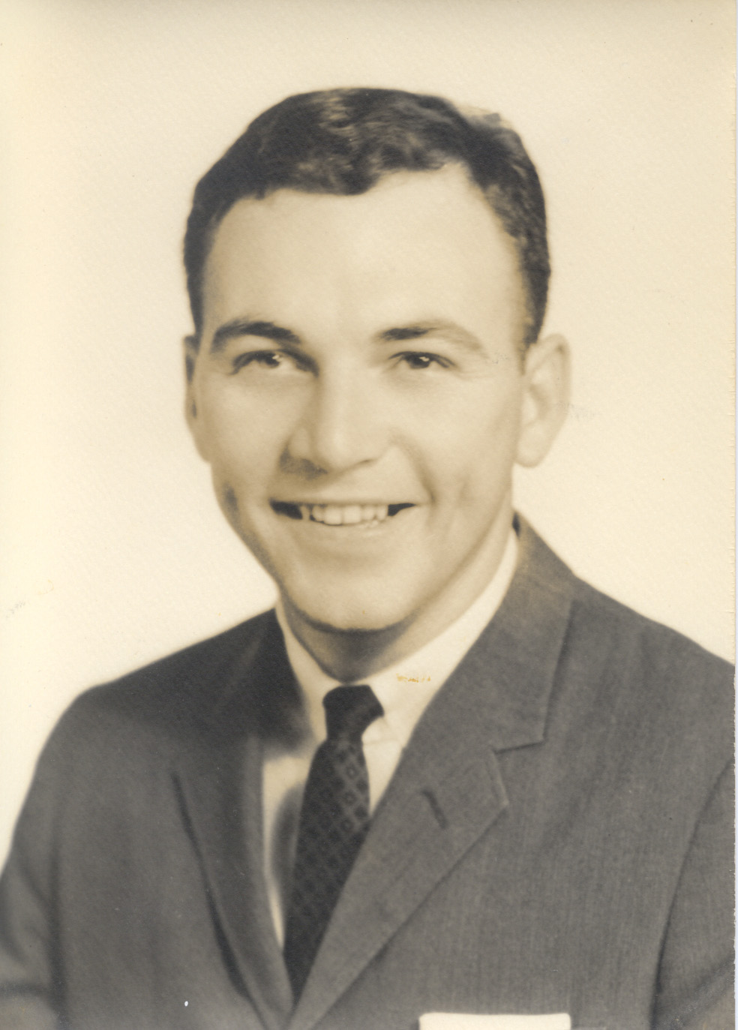 | Player 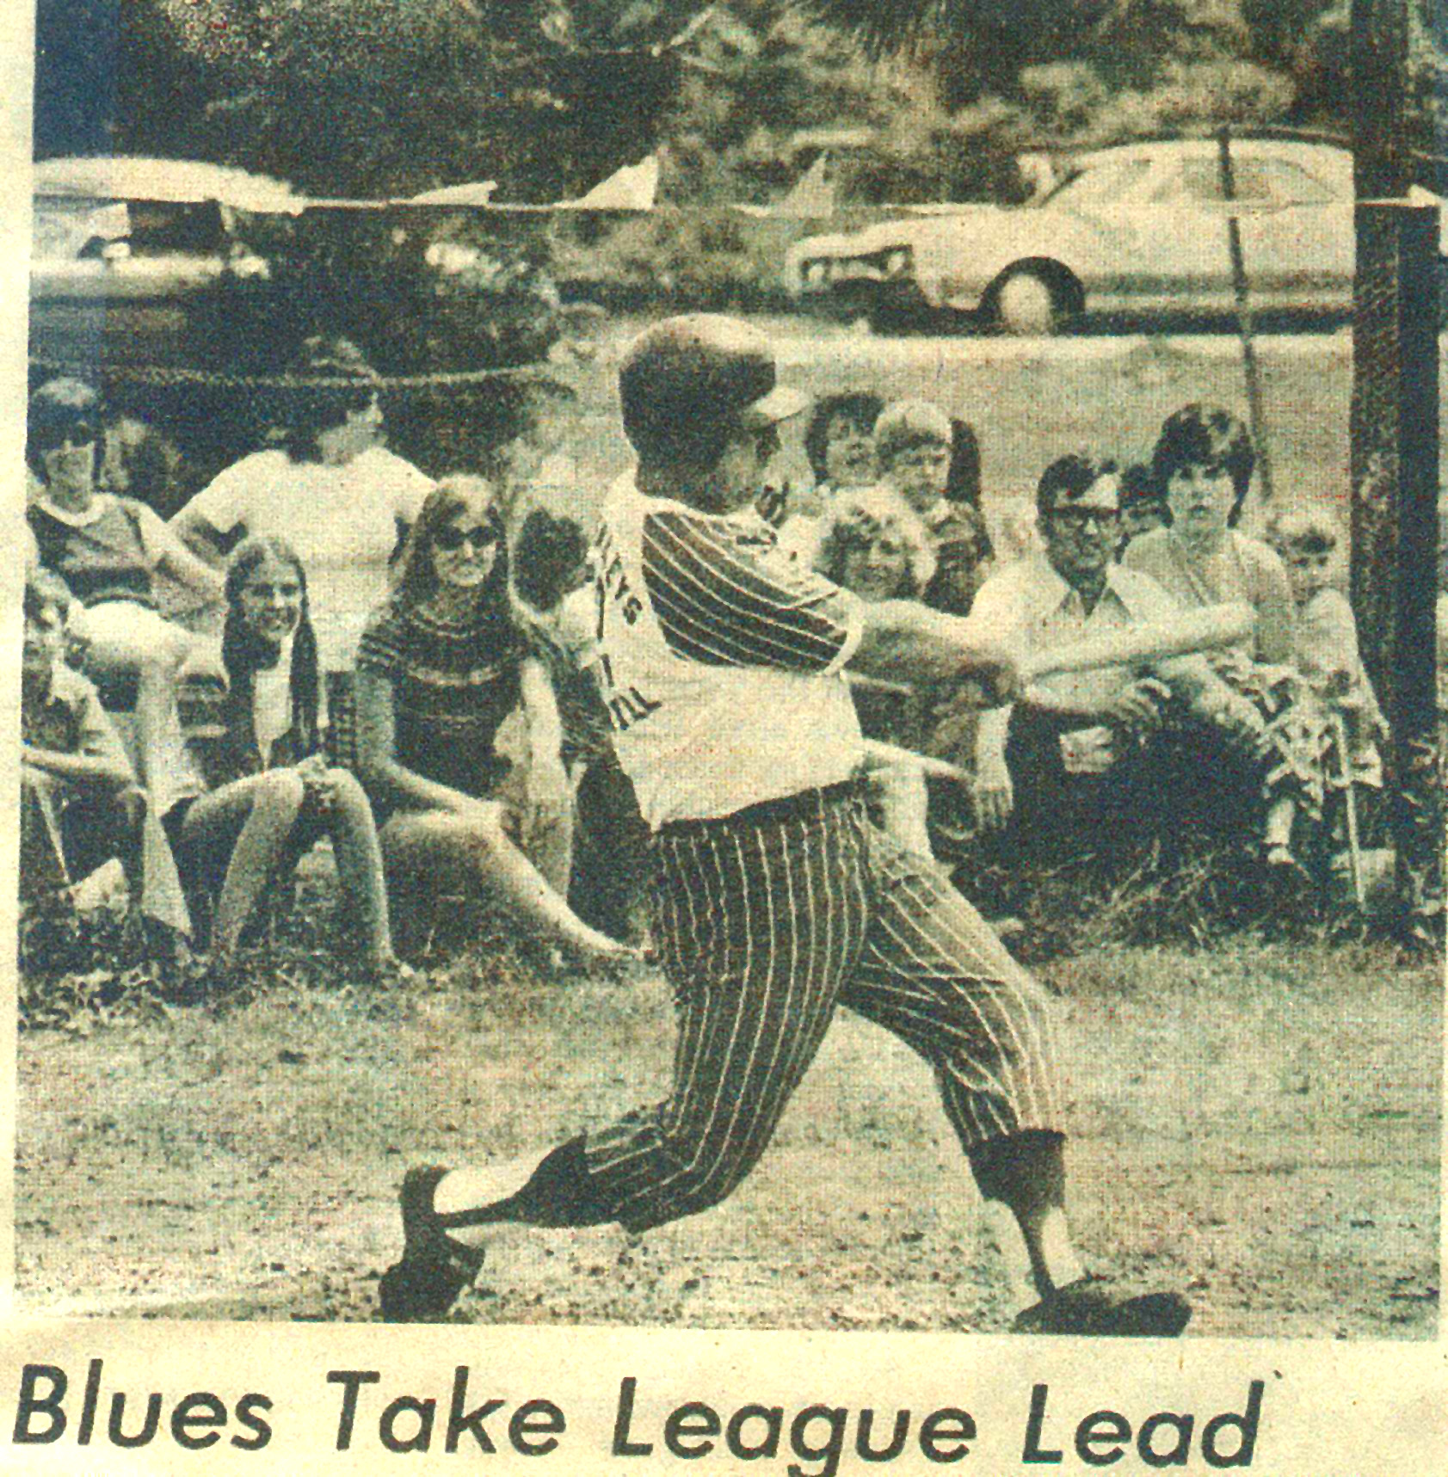
- At his own expense, he dedicated 5 ½ years (7,000 hours) documenting for CSWM&HC Carteret
County Sports History form 1920s through 2009. Including Game by Game for all of the semi-
pro teams played from 1940s which included 17 years.
- He started four computer software companies which have employed more than 2,000 employees, and two of his
companies were sold to Fortune 500 companies. His companies were recognized as leading edge.
- Founder and organizer of the Eastern Blues of the Seashore League 1974-1977 the most successful semi-pro baseball team ever in the County, winning 88% of their games.
- With the Eastern Blues, he was the batting Leader in 1974 batting .529, also batted .319 in 1975. His
knee and moving to Winston Salem for work in 1976 allowed him to play in limited bases.
- Taught math and Coached Baseball at ECHS (1968-1971), and Assisted with Football.
- Coached the first Co-Championship Baseball team at ECHS 1970.
- Coached Pony League one year, and Coached Basketball first year at Carteret Tech.
- He was a member of the Golden Knot Honor Society and graduated first in his class from Atlantic Christian where he attended on a baseball and academic scholarships.
- Mid-season of his Junior Year, he was Batting .500 when injured right knee which
would end his hopes for pro ball possibilities.
- Attend Chowan on a scholarship played baseball for two years before being recruited
by Atlantic Christian. He was the Most Valuable Player in 1966 – Led League in Batting
.396, and led league in stolen bases.
- Attended Smyrna HS where he played basketball and baseball all four (4) years.
- He was the starting catcher for the 1962/63/64 Smyrna HS and was the catcher for the
County 1963 Championship Baseball team batting .340.
- Played guard for the 1964 Smyrna Basketball Championship Teams was All-Tourney, 2nd Team ALL-County,
&Top 10 Scorer at #8 averaging 14.5 points per game & known for his defense ability. He also was
named to the All-County 1963 Smyrna Basketball Team.
- Known for Hustle and Clutch Hitting Started in Pony League:
  - 1960 Smyrna Pony League – Batted .500
  - 1961 Smyrna Pony League – Batted .476

